**Hands On Assignment 2**

**Bhuvanesh P – MM19B027**

(i) The graph is given below with equation below it

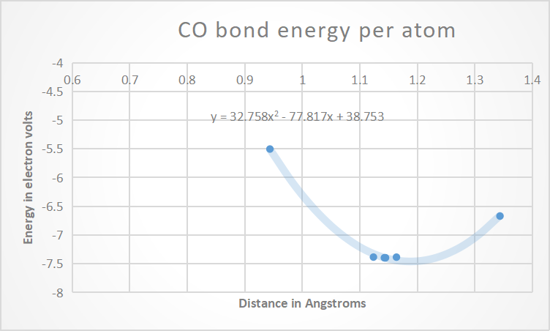

The equation is given by y = 32.758x2 - 77.817x + 38.753

(ii) $ω=\sqrt{\frac{α(w1+w2)}{w1 w2}}$

The equation above gives the vibrational frequency of atoms.

We get $α$ after double differentiating the energy equation with respect t o distance

$α=\frac{d^{2}E}{dx^{2}}$ = 2 x 32.758 = 65.516

This is not in SI units to convert it we need to multiply by 1.6 X 10-19 in numerator and 10-20 in the denominator

$α=\frac{65.516X1.6X {10}^{19}}{{10}^{-20}}=1048.256$

$$w1=\frac{12}{6.023X{10}^{-23}}$$

$$w2=\frac{16}{6.023X{10}^{-23}}$$

After substituting $ω$ is given by

$$ω=\sqrt{\frac{1048.256(\frac{12}{6.023X{10}^{23}}+ \frac{16}{6.023X{10}^{23}})}{ \frac{16}{6.023X{10}^{23}} \frac{12}{6.023X{10}^{23}}}}$$

$= \sqrt{\frac{10482.56 X \left(28\right) X 6.023}{192}} X {10}^{12}$

$$=95.9551 X {10}^{12} Hz$$